**Detailed explanation:**

**Generate the Server Logs**

1>When ./generate.sh script is run, after every minute 1000 files will be written in the folder specified.

From the time when you run the script till the end of the day every minute the logs will be written to the files.

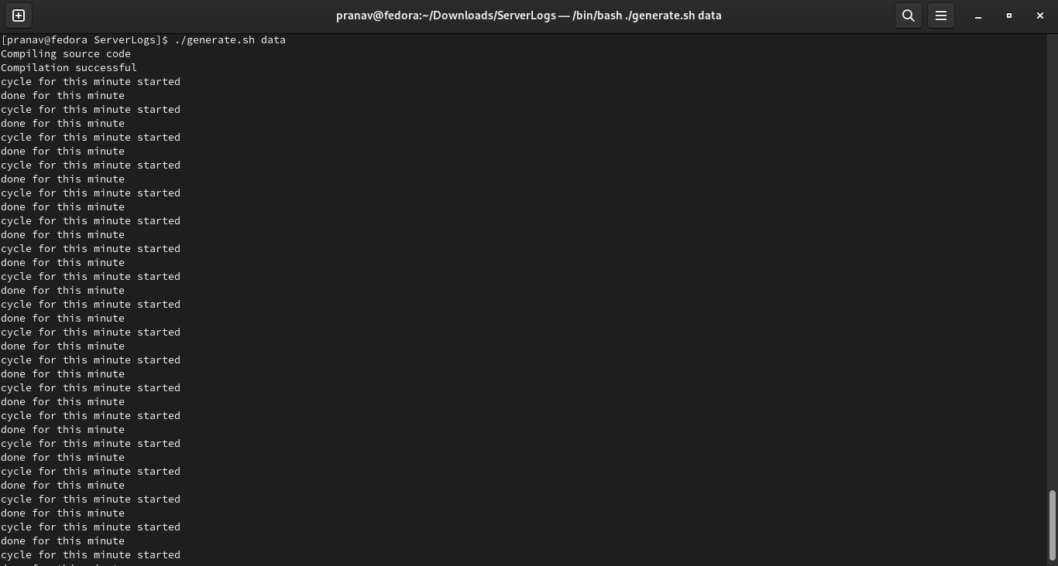

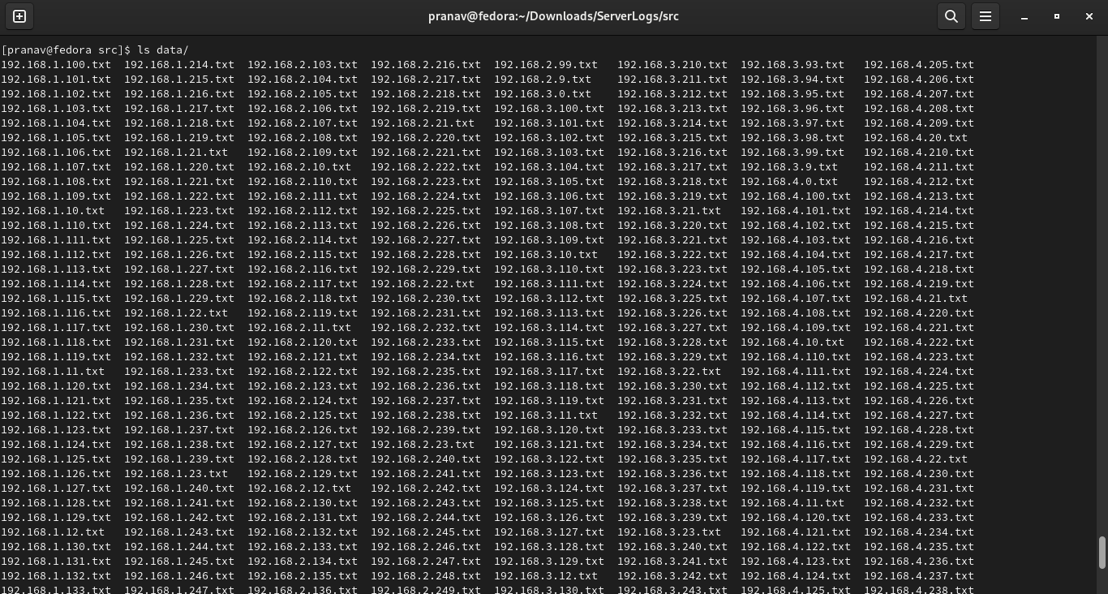

Total there are 1000 servers. For every server 1 file will be created , filename being the ip address of the server.

These files will be created in the folder specified while running the generate.sh script.

The folder will be created in the ServerLogs/src folder.

**Query the Server Logs**

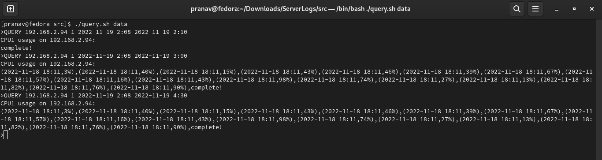

As shown in the screenshot for quering the logs query.sh script should be run